472 - W OD

L*FDNES:

RAÆOSDE

ETE - SJp

DECOEaaon›ivÂOx•I7524»,.• SEtï3.g,

DEMONSxeATIVO DAO CEITAS E D£,SPESAg

EXERCÏCIO:2it2I

"'**°°nixzs*nc

**°'****J 7*‹ zu,»



472 'FUs

°”**'-'”**“K’O“P•m’”od’“ea“œ“v«e•fid«

'**°*-°”*»“^°•*•«•rawvbwsapd.e. w ”-*° *-••«=••

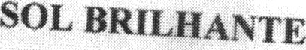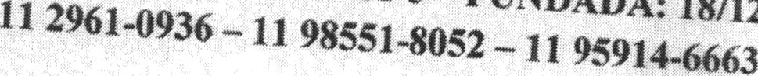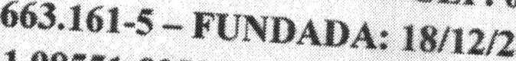

••••æ

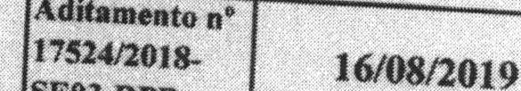”""” ”•* •- „‹o„, ,

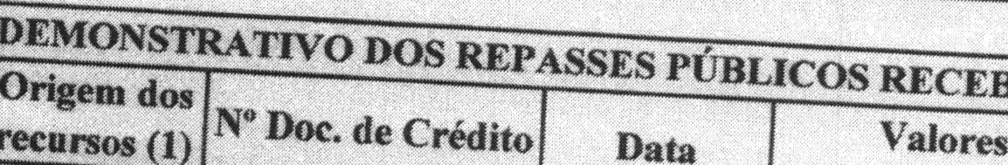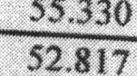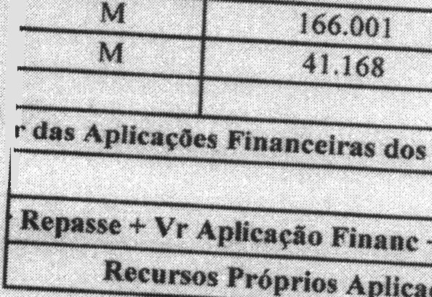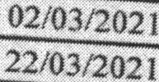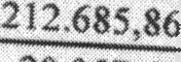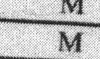

432 437,34

20.057,60

2.860,74

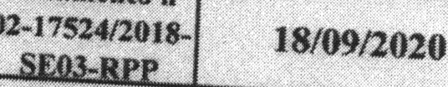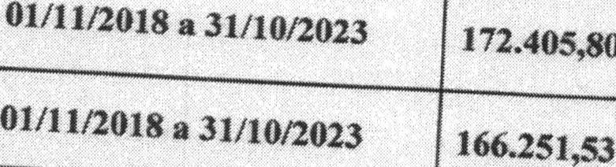

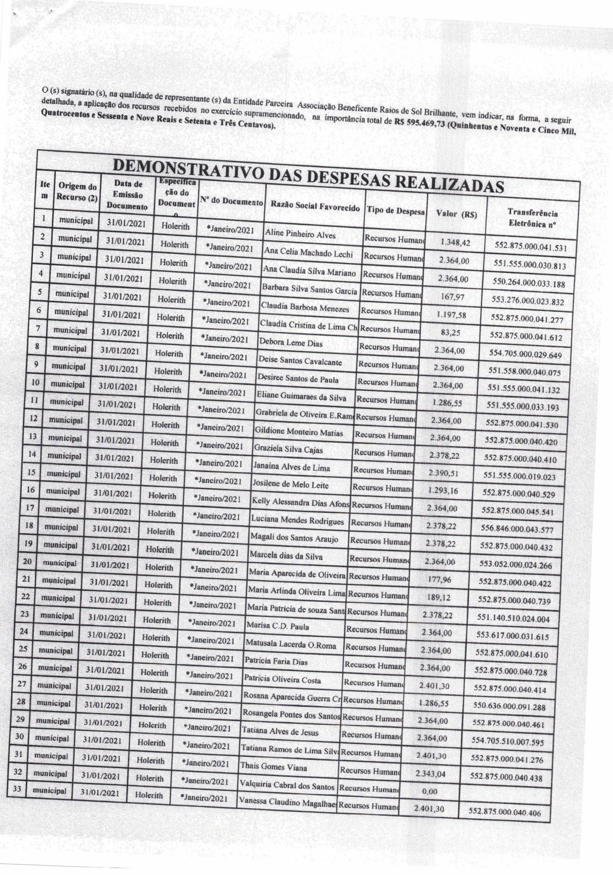



Only two pages were converted.

Please **Sign Up** to convert the full document.

[**www.freepdfconvert.com/membership**](https://www.freepdfconvert.com/membership)